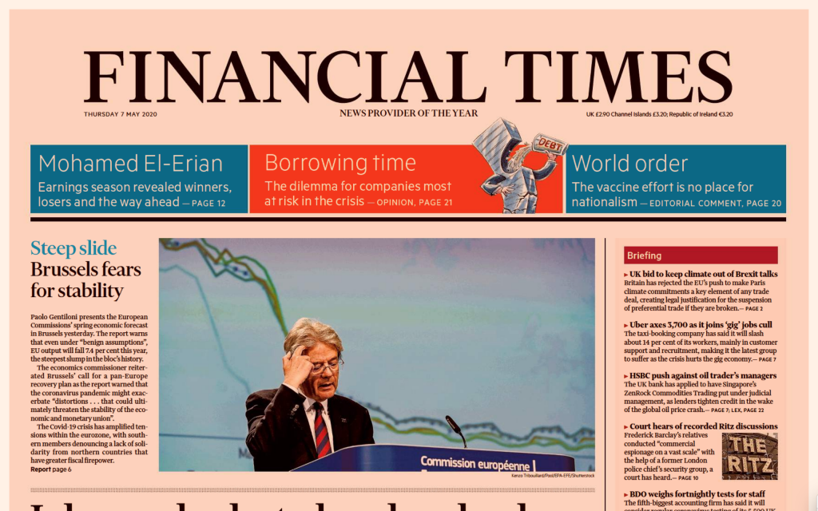
Media lies threaten the truth and decency on which democracy depends | Financial Times (ft.com)

Media lies erode bedrock of democracy
One has to hope that the electorate and judiciary will remain robust against future efforts at subversion
MARTIN WOLF MAY 3, 2023

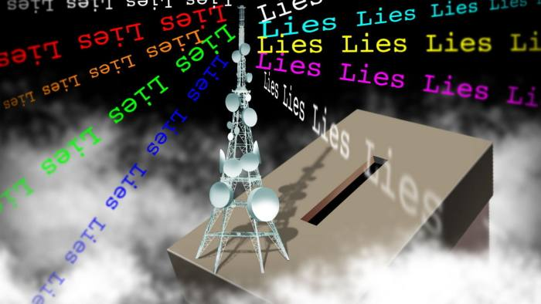
© James Ferguson

Last month, Fox, a business controlled by Rupert Murdoch and his son Lachlan, agreed to pay $787.5mn to Dominion Voting Systems to settle the latter’s $1.6bn defamation case against it. Justin Nelson, Dominion’s lawyer, insisted in response to this settlement that it shows that “the truth matters” and “lies have consequences”. This is true, but only to a limited extent.

The business model revealed in startling detail in exchanges among Fox executives and stars depends on giving its viewers the red meat they want. If that includes falsehoods, so be it. Asked whether he could have told the top people at Fox to stop putting Rudy Giuliani (one of the most assiduous promoters of lies about the 2020 US election) on air, Rupert Murdoch replied “I could have. But I didn’t.” His inaction revealed all.

As the late senator Daniel Patrick Moynihan said: “You are entitled to your opinion. But you are not entitled to your own facts.” Facts can sometimes be debated. But very frequently, as in this case, falsehood cannot be: these are not “alternative facts”, but lies. In Truth and Politics, Hannah Arendt tells a story about Georges Clemenceau, leader of France at the end of the first world war. Asked who was responsible for the war, he replied: “I don’t know. But I know for certain they will not say Belgium invaded Germany.” Donald Trump did not win the presidential election of 2020. His allegations of fraud are lies.

Needless to say, totalitarian regimes of both left and right have promoted falsehood freely. For them, lies were (and are) an instrument of control. Democracies are supposed to be different and, in this case, they were, in one important respect. The independent truth-revealing mechanism of the law forced Fox to display its awareness that it was spreading outright falsehoods.

Do such lies matter? Very much so. In the absence of agreement on the facts, democratic debate can barely start. But these lies have a particularly powerful significance, because they were (and are) an attempt to overthrow democracy itself.

Democracy can be defined as a civilised civil war. It recognises the existence of differences of opinion, but resolves these peacefully, through elections, which are the fundamental institution of representative democracy. Elections determine legitimacy. But to do so they must be recognised as fair

A lie about the outcome of an election, then, is not just any lie. It is not even just any political lie. It directly threatens democracy. It is an attempt to overthrow elections as the arbiter of power. That is what Trump tried to do. It is what all those who supported or enabled him have tried to do. It is what Fox’s coverage of the election, not least the endless promotion of lies about the safety of the voting, tried to do.

That is not a minor delinquency which the world should easily forget. Democracy is endangered across much of the world, while the US is the world’s most significant democracy. Attempts to subvert democracy’s core institution in its heartland are unpardonable. Yet they are, alas, not surprising. As the British journalist Matthew d’Ancona argues in Prospect, Fox was “like the scorpion in the well-known fable, stinging the frog of democracy it was being carried on, sinking them both into a quagmire of dishonesty, disinformation and disorder. It was simply being true to its nature. It still is.”

A defender might argue that none of this was Fox’s fault. It just did what it had to do, in order to give its customers what they wanted. This, one might note, is what a drug dealer would argue. In this case, moreover, Fox was not just satisfying a pre-existing desire. It played a significant part in creating the addiction to extreme rightwing demagoguery, of which Trump is so brilliant an exponent. As Jim Sleeper has noted in the Columbia Journalism Review: “Fox surrenders, or retargets, journalism not only to entertain but also to stoke and channel rivulets of public anger and fear into torrents of political power.”

Imagine what would happen if a future presidential election were to be even closer. Institutions might then be stretched beyond breaking point. Yet, maybe, it is already too late to do anything about it. Given current deep divisions, any attempt to update the old “fairness doctrine” (suspended in 1987) to cover today’s broadcasters would be unacceptable and unworkable. One can argue, too, that it is impossible to prevent the widespread dissemination of lies, given our social media. All one has is the hope that the electorate and judiciary will remain robust against future efforts at subversion.

For those countries that have not yet fallen into these swamps, however, it is vital to protect the funding and independence of public service broadcasters, such as the BBC, and to insist that all broadcasters have an obligation not to tell lies. Should they break this obligation, they should promptly lose their licences, which are a privilege not a right. They do not entitle broadcasters to preach sedition against the democratic polity that gave birth to them.

One has to remember three big things about the market economy. The first and most fundamental is that one must not do everything that is profitable. Indeed, there has to be a lengthy list of activities one is not entitled to do. The second is that some of the things one must not do might be legal or, if contrary to law, hard to prevent. The last and most important therefore is that the survival of a civilised society depends on moral restraint, particularly from its leading figures. In 1954, Joseph Nye Welch, chief counsel for the US army, responded to the red-baiting of Senator Joe McCarthy by asking “Have you no sense of decency, sir?” Free societies will die if those with influence, wealth and power lack that virtue.

martin.wolf@ft.com Follow Martin Wolf with myFT and on Twitter

